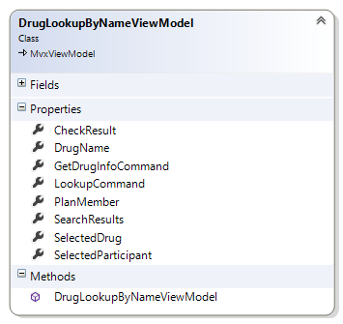

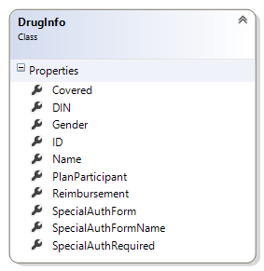

# DrugLookupByNameViewModel

Drives the lookup by name process (pp 8 – 14 GSC Mobile Solution iPad Wireframe).

## Properties

DrugName -> the generic or brand name of the drug to be checked (ie Tylenol)

PlanMember -> The planmember (including the list of dependents) currently logged in

SelectedParticipant -> Of the PlanMember, or dependents, the single item selected from the List of potential people

SearchResults -> When searching by Drug Name, the service will return a complete list of candidate drugs (ie Tylenol & Codeine, TYLENOL 80MG CHEWABLE TABLET, etc)

SelectedDrug -> Of the returned drug, the specific drug selected from the list

CheckResult -> After the GetDrugInfoCommand has been executed, the detailed result of the inquiry as a DrugInfo object

## Commands

*Reminder* a reference to System.Windows must be set in the References for the ICommand interface to be available. Command bindings will not work without this. This is particularly important to remember when working in iOS projects

LookupCommand -> Executes a search service call asking for all drugs that contain the DrugName property

GetDrugInfoCommand -> Executes an inquiry to determine the selected Participant’s coverage elegibility for the selected drug.a